**Brooklyn torah gazette**

**For yom tov shavuos 5783**

Volume 7, Issue 36 (Whole Number 343) 6-7 Sivan 5783/ May 26-27, 2023

**Printed L’illuy nishmas Nechama bas R’ Noach, a”h**

For a free subscription, please forward your request to [***keren18@juno.com***](mailto:keren18@juno.com)

**Shavuos Customs**

**By Rabbi Shimon Finkelman**

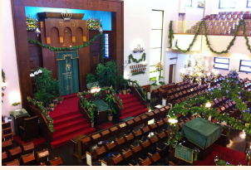

**Greenery and Flowers**

It is customary to decorate the shul and one’s home with greenery in honor of Shavuos (Rama 494:3). · This custom serves to recall Mount Sinai, which was surrounded by foliage, as it is written (Shemos 34:3), “Even the flock and the cattle may not graze facing that mountain” (Mishnah Berurah 494:10). ·

This custom is also a reminder that Shavuos, when fruits of the trees begin to ripen, is a time of Heavenly judgment regarding the coming fruit harvest (see Mishnah Rosh Hashanah 1:2); a time of judgment demands a heightened level of prayer.

The Sages teach (Rosh Hashanah 16a) that the offering of Shtei HaLechem, Two Loaves, was brought on Shavuos in order to invoke G-d’s blessing on the fruit harvest (Magen Avraham 494:5). Bnei Yissachar writes that it is customary “to prepare roses and other fragrant plants for Shavuos and also to decorate the Torah scrolls with them.”

**Night-Long Torah Study**

A well-established custom, calls for studying Torah throughout the night on the first night of Shavuos. This custom has its source in Zohar. The Magen Avraham (494:1) cites the following Midrash as a reason for this custom:

During the month of Sivan, the day is considerably longer than the night and the dawn comes quite early. On the day the Bnei Yisrael was to receive the Torah, the people overslept. The sun had already risen, G-d’s Presence was manifest upon Mount Sinai, yet the people were still sleeping!

Moshe went through the camp to arouse them. He cried, “Arise from your sleep! The Groom [G-d] has already arrived. He seeks the bride [the Bnei Yisrael] that He may lead her to the chuppah (marriage canopy). He is waiting to present her with the Torah” (Pirkei D’Rebbi Eliezer 41).

As atonement for the Jews having overslept, says the Magen Avraham, the pious of earlier generations would study Torah throughout the night of Shavuos. In later generations, the custom was adopted by Jews of all walks of life and level of scholarship.

**No Atonement Necessary for Having Overslept**

However, Rav Tzadok Hakohen of Lublin (Pri Tzaddik) contends that nowhere does the Midrash say that atonement was necessary for the Jews having overslept. He argues that their sleep was intentional, as a form of preparation for the Revelation that was to come.

Prophecy was usually experienced in the form of a dream, as it is written, “If there shall be prophets among you, in a vision shall I, Hashem, make Myself known to him; in a dream shall I speak to him” (Bamidbar 12:6).

Scripture records that both Yaakov and Shlomo experienced prophetic dreams. The Jews intended that their sleep should represent a total subjugation of their senses to G-d, and that it would be a means through which they could attach themselves to Him and ready themselves for the Revelation, when they would hear the voice of G-d while fully alert.

While the custom of all-night Torah study on this night was recorded almost two millennia ago, until four centuries ago it was observed by only small groups of scholars. Widespread acceptance of the custom was first popularized by the scholars and Kabbalists of Tzefas.

**Dairy Foods**

The Torah states: “Vesamachta bechagecha - You are to rejoice on your festival”(Devarim 16:14). From here the Sages derive: “One is obligated to be joyous and happy of heart on the Festivals, together with his wife, children, and everyone else who is with him” (Shulchan Aruch, Orach Chaim 529:2).

In Temple days, men fulfilled this commandment through eating sacrificial meat. Today, when there is no Temple, one fulfills this obligation by drinking wine, and it is a mitzvah to eat meat, since it is this which is implied in the command to rejoice (Be’ur Halachah 529:2, s.v. Keitzad).

Shavuos is the only Scriptural Festival on which there is a custom to also partake of dairy foods, especially on the first day. An allusion to this custom is found in the words “Uveyom habikkurim behakrivchem minchah chadashah laShem beshavu’oseichem - On the day of the first fruits, when you offer a new meal-offering to Hashem on your Festival of Weeks” (Bamidbar 28:26).

The first letters of chadashah laShem beshavu’oseichem form the word chalav, milk (Mateh Moshe). According to the Rema (Orach Chaim 494:3), this custom is a remembrance of the Shtei HaLechem, Two Loaves, which were offered in the Temple on Shavuos. One is permitted to begin a meal with dairy, and after rinsing out his mouth and making other preparations, based on custom and necessity, he may then eat meat. However, bread that was on the table when dairy was served should not be used with meat (Yoreh De’ah 89:4). Thus, by beginning the meal with dairy and ending it with meat, one is forced to use two different breads, a remembrance of the Shtei HaLechem.

**The Insight of the Chofetz Chaim**

The Chofetz Chaim writes (ibid. §15-17) that it is customary to bake a dairy bread for the first part of the meal, for this will ensure that the bread will be removed before the meat is served. Generally, the Sages prohibited the baking of dairy breads, lest these breads be eaten inadvertently with meat (Pesachim 30a).

However, two exceptions to this prohibition are where only a “small amount” of dairy bread is baked, or where the dairy bread is baked in a distinctive form that clearly sets it apart from regular bread. These exemptions are the basis for baking a dairy bread for the Shavuos meal (Rema, Yoreh De’ah 97:1).

It should be noted that today, many fulfill the custom of eating dairy in a different way. Halachah states that Kiddush on Shabbos or the Festivals be recited in conjunction with a meal (Kiddush Bemakom Seudah). One may fulfill this requirement by eating the necessary amount of bread, cake, or other food of the five grains following the recital of Kiddush over a cup of wine.

On Shavuos day, many serve dairy foods, such as cheesecake or blintzes, with Kiddush, and later eat a meat meal. Since these grain foods are, according to halachah, considered a form of bread, partaking of them and then eating bread at the Festival meal could also be considered a remembrance of the Shtei HaLechem. Others eat a dairy meal on the first night of Shavuos and fulfill the mitzvah to eat meat at the daytime meal.

*Reprinted from the Parshas Bamidbar/shavuous 5782 edition of At the ArtScroll Yom Tov Table. Excerpted from the ArtScroll sefer “Shavuos: Its Observance, Laws and Significance” by Rabbi Shimon Finkelman.*

**The Significance of the Number 3 And the Giving of the Torah**

**From the Teachings of the Lubavitcher Rebbe**

**Rabbi Menachem Mendel Schneerson, Zt”l**

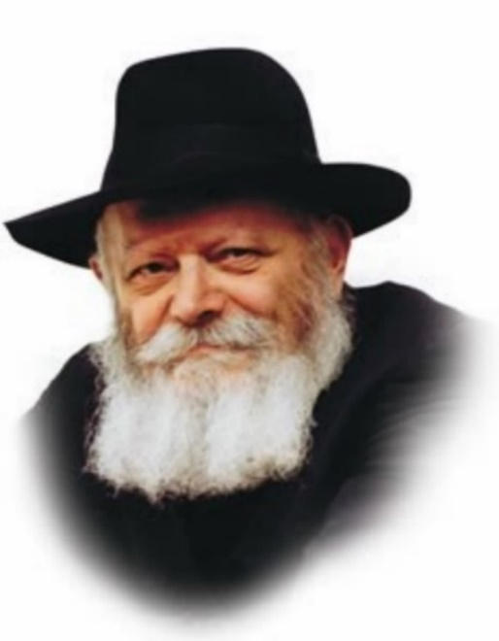

The giving of the Torah to the Jewish people on Shavuot occurred in Sivan, the third month of the year. (The Torah counts the months beginning with Nisan, when the Jews went out of Egypt.)

This fact is significant, for there is an essential connection between the number three and the Torah itself.

Commenting on the special significance of the number three, our Sages stated: "The three-fold Torah [the Five Books of Moses, Prophets and Writings] was given to the three-fold nation [Kohanim (priests), Levites and Israelites] in the third month [Sivan]."

Every month of the year is characterized by its own unique service of G-d.

The first month of the year is Nisan. It was in Nisan that the Jewish people left Egypt and merited an extremely intense revelation of G-dliness. During Nisan, the Jewish people is guided from "Above." Just as it was G-d Who initiated the Exodus and revealed Himself with wonders and miracles, so too is our Divine service during Nisan "directed" from Above, independent of our initiative.

**The Importance of the Counting of the Omer**

The service of the month of Iyar, by contrast, entails a great deal of effort on the part of the Jew. Every day of the month we count the omer, in preparation for the giving of the Torah on Shavuot. Counting the omer enables us to refine our midot (character attributes) and ascend, step by step, the rungs of spiritual achievement. Because this service originates from "below," the progress we make is entirely dependent on our individual effort.

Nisan and Iyar, the first and second months of the year, are therefore symbolic of opposite and even contradictory approaches to the service of G-d. The first approach, alluded to by the month of Nisan, is in itiated by G-d, Who arouses us to serve Him and leads us in the right direction. In Iyar, however, it is we who must supply the initiative.

**Uniting G-d and the Jewish People**

These opposite thrusts are resolved and integrated into a comprehensive whole in the month of Sivan, the third month of the year, with the giving of the Torah. The Torah unites G-d, the Giver of the Torah, with the Jewish people, its recipient.

By studying Torah, the Jew achieves a union of his own limited intellect with the infinite wisdom of G-d, thus creating a third entity: a true unification and bond between G-d and Israel. The giving of the Torah and the month of Sivan thus share an inner and essential connection.

*Reprinted from the Parshat Bamidbar 5760/2000 edition of L’Chaim. Adapted from Volume 2 of Likutei Sichot.*

**Rav Avigdor Miller on**

**Verified Sinai Traditions**

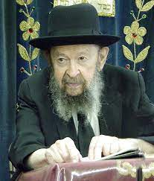

**QUESTION:** It says כל המלמד את בן בנו תורה מעלה עליו הכתוב כאילו קיבלה מהר סיני – that if you teach your son or grandson Torah it’s as if he received it from Har Sinai (Kidushin 30a). What does that mean that he’s receiving it from Har Sinai?

**ANSWER:** We must understand one fundamental fact. We don’t have any emunah – it means there’s no such thing as a commandment for a Jew to believe in Ma’amad Har Sinai. It’s not a special mitzvah, no. And that’s because Ma’amad Har Sinai is history.

I’m going to explain that to you, a very important fact. At Ma’amad Har Sinai there were two million witnesses. Everything that happened in the midbar, all the nissim, were witnessed by millions of people. That’s why the last words in the Torah are לעיני כל ישראל – before the eyes of all of Israel. The nissim were done le’eini kol Yisroel.

**All Other Religions were Invented without Witnesses**

That’s very important. That’s why never do you find curses in the Torah on people that didn’t believe in that. I mentioned already that in the Koran lehavdil and in the New Testament lehavdil it’s full of curses on those who disbelieve; that’s because there’s a reason to disbelieve. There are no witnesses! All the stories were invented without witnesses.

The Am Yisroel on the other hand has a history that states that more people were present at Har Sinai than ever saw lehavdil George Washington. More people were present at Har Sinai than ever saw any one of our presidents. At one time two million people were present. Six hundred thousand between the ages of twenty and sixty besides older and younger and women. Two million people at least. That’s why never do you find in the Torah or in the Tanach anybody is blamed that he didn’t believe in our history. And therefore, we have no question of emunah. It’s common sense; it’s our history.

I’ll explain to you. Recently there was a headline in the New York Times. About what? They were very happy that a certain rasha who in charge of education in the State of Israel was undertaking now to stop teaching Jewish children “ancient myths”, old-time stories. “Ancient myths” means the Torah; that’s what the New York Times calls it – “ancient myths.”

**Verified by Josephus the Historian**

Now, what’s so ancient about it however? Two thousand years ago Josephus wrote in his history all the events of the Torah; so, take off two thousand years. Two thousand years ago we’re standing now with Josephus. The Torah is not very old then. However, even before Josephus, four hundred years before Josephus, the Torah was translated into Greek. It was in the possession of the gentiles. The Septuagint, the Greek translation of the Torah, was in the hands of goyim.

So, four hundred years before the churban we already had the Torah. The gentiles are testifying to that! We don’t need it—we understand that we had it all the time—but the gentiles are testifying!

Now look at the Kusim, the Samaritans. The Samaritans have only Chumash and Sefer Yehoshua. Why don’t the Samarians have Shmuel Alef and Shmuel Beis, Malachim Alef and Malachim Beis? You hear that question: Why do the Shomronim not have anything except the Chumash and Sefer Yehoshua?

**The Books Written by Samuel the**

**Prophet were Not Yet Widespread**

The answer is that when the aseres hashevatim broke away in the days of Yeravam ben Nevat—that’s right after Shlomo Hamelech—at that time the sefarim were not yet popular. The sefarim written by Shmuel Hanavi were not yet widespread. They didn’t have printers to print a thousand books at one time.

So, the Chumash and Sefer Yehoshua were the only ones available and that’s what Yeravam ben Nevat took along – after all he wouldn’t take along Sefer Melachim that it speaks against him; and therefore, it didn’t exist the Sefer Melachim by him. So therefore, when Yeravam ben Nevat broke away that’s all he took along and so the ten tribes only had the sefer of the Chumash and Sefer Yehoshua.

Then, when the ten tribes were sent into exile the Kusim, gentiles, were brought into the land and then when the lions began terrifying the gentiles, the Kusim, they called back kohanim of the Aseres Hashevatim and these kohanim taught them the religion of the Aseres Hashevatim; and they taught them what Yeravam ben Nevat had taken along – Chumash and Sefer Yehoshua and that’s all.

So now, if you want a testimony to the recency of the Torah go up to Har Greizim today in Eretz Yisrael and look at the books, at the sefarim of the Shomronim. You’ll see they only have Chumash and Sefer Yehoshua. It shows that the Chumash and Sefer Yehoshua were already in the hands of Yeravam ben Nevat. Ancient? There’s nothing ancient about it. Nothing ancient at all.

If you want more, Moshe Rabeinu is described in Tehillim. Tehillim describes Matan Torah only five hundred years after it happened. Tehillim is only five hundred years later.

**Our History is Not as All Recent**

So, therefore our history is all recent. It’s not ancient at all. It’s not a matter of belief. Nobody ever had a question of believing in the Torah. And therefore, we don’t find anybody who is blamed for disbelieving in the Torah. Everybody understood that’s our history. Our history is more certain than all the histories of the history books. Nothing in all the books of the gentiles is as genuine and is as deserving of credence as is the history of the Am Yisrael. We’re the ones who have the most solid foundation for all the things that we have in our traditions.

Now this is not merely talk. We can prove it scientifically. They’re not my words. They’re words from Isaac Halevi, a great doresh and a scientist in Tanach. And therefore, the whole history of the Jewish people is clearly stated in the words of the Torah and in the words of the nevi’im. And the gentiles who came later all cherished our sefarim; they cherish our books to this day. Even Oso Ha’ish quotes constantly from our books. And these books all state all of our history; which means in the time of the Beis Hamikdash when these people lived everybody knew that these were the facts of history.

**A Very Important Point**

And so, there’s no question of belief among the Am Yisrael. It’s a very important point that you heard just now.

And therefore, when you teach your son Torah, you should know you are a recipient of a tradition that you gained from your father and your rebbi and he from his father and his rebbi and so on. It’s an unbroken chain of tradition. And so, when you teach your son Torah you should know that the son is getting it from Har Sinai, from the most reliable witnesses. In every generation the father is handing down what their fathers had told them that they had seen with their own eyes. And therefore, when you teach your son Torah, you’re teaching him as if he was present and he himself was at Har Sinai to listen.

*Reprinted from a recent Toras Avigdor email based on Rabbi Miller’s Tape # E-241 from a classic Thursday night lecture in August 2000..***Magic of Shavuot 1967**

**By Larry Domnitch**

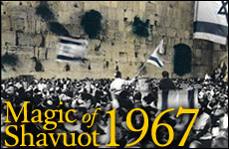

Over the last two millennia, Jews have visited Jerusalem in honor of the festivals, in lieu of the biblically-ordained pilgrimages. On the holiday of Shavuot, there was also the custom to visit the purported grave of King David on Mount Zion, since the date of his death was on Shavuot.

When Shavuot arrived in 1948, it was a month after the establishment of the State of Israel, and Jews could no longer continue to make the pilgrimage to the Western Wall. The Jordanians, who occupied the eastern half of the city since the War of Independence, blocked all rights of passage to the Jews. However, the pilgrimage to King David's tomb on nearby Mount Zion, located on the Israeli side of divided Jerusalem, continued. Over the next 19 years, crowds made their way to Mount Zion, where across barbed wire they could view the Old City and the Temple Mount.

On the morning of Shavuot, June 15, 1967 – just six days after the liberation of the Old City of Jerusalem in the Six Day War – the Old City was officially opened to the Israeli public. (The army wanted to be sure there were no landmines or snipers still in the Old City.) For the first time in almost 2,000 years, masses of Jews could visit the Western Wall and walk through the cherished streets of Judaism's capital city as members of the sovereign Jewish nation. Each Jew who ventured to the Western Wall on that unforgettable day was realizing their ancestors' dreams over the millennia. It was one of those rare, euphoric moments in history.

From the late hours of the night, thousands of Jerusalem residents streamed toward the Zion gate, eagerly awaiting entry into the Old City. At 4 a.m., the accumulating crowds were finally allowed to enter the area of the Western Wall. As the sun continued to rise, there was a steady flow of thousands who made their way to the Old City.

**Every Section of the Jewish Nation Came**

The Jerusalem Post described the epic scene:

Every section of the population was represented. Kibbutz members and soldiers rubbing shoulders with Neturei Karta. Mothers came with children in prams, and old men trudged steeply up Mount Zion, supported by youngsters on either side, to see the wall of the Temple before the end of their days.

Some wept, but most faces were wreathed in smiles. For 13 continuous hours, a colorful variety of all peoples trudged along in perfect order, stepping patiently when told to do so at each of six successive barriers set up by the police to regulate the flow.

In total, 200,000 visited the Western Wall that day. It was the first pilgrimage, en masse, of Jews to Jewish-controlled Jerusalem on a Jewish festival in 2,000 years, since the pilgrimages for the festivals in Temple times.

An eyewitness described the moment:

"I've never known so electric an atmosphere before or since. Wherever we stopped, we began to dance. Holding aloft Torah scrolls we swayed and danced and sang at the tops of our voices. So many of the Psalms and songs are about Jerusalem and Zion, and the words reached into us a new life. As the sky lightened, we reached the Zion gate. Still singing and dancing, we poured into the narrow alleyways beyond."

**The Eternal Magic of this Moment**

On [Shavuot, 3,279](https://www.sefaria.org/Mishnah_Shevuot.3.279?lang=he-en&utm_source=aish.com&utm_medium=sefaria_linker) years earlier, the Israelites stood at Mount Sinai and forged a relationship with their Creator. On the day of Shavuot following Israel's amazing victory in the Six Day War, multitudes ascended to the Western Wall, and they, too, felt the eternal magic of this moment. After all, "For from Zion shall come forth Torah, and the Word of God from Jerusalem."

This "pedestrian pilgrimage" has now become a recurring tradition. And on this year as well, early on Shavuot morning – after a full night of Torah learning – the streets of Jerusalem will be filled with tens of thousands of Jews, walking with and anticipation and awe to the Western Wall.

*Reprinted from the 2023 Shavout website of aish.com*

**Where is Mount Sinai?**

**By**[**Yehuda Shurpin**](https://www.chabad.org/search/keyword_cdo/kid/15169/jewish/Shurpin-Yehuda.htm)

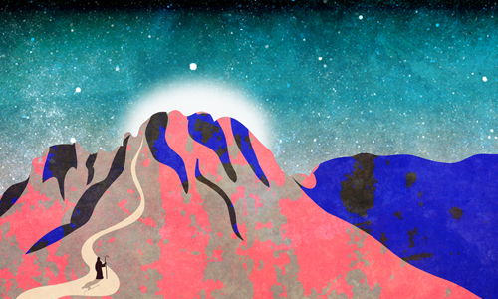

***Art by***[***Sefira Lightstone***](https://www.chabad.org/3159160)

I’ve seen lots of theories about the location of Mount Sinai. Is there any validity to those theories? I know that Judaism reveres the Temple Mount as the site of the Holy Temple, but is there any location that Judaism reveres or at least recognizes as Mount Sinai, the place where G‑d gave the Torah and where the Jewish nation was born? And if not, why?

**Reply**

There are lots of theories, but none of them are even close to conclusive. Why is that? Why have the Jewish sages not preserved a tradition regarding the location of the most monumental event in all of history? Why the ambivalence?

Once the Jewish people received the [Torah](https://www.chabad.org/library/article_cdo/aid/1426382/jewish/Torah.htm) on Mount Sinai and continued their journey to the Land of Israel, there is just one biblical mention of anyone going back to Mount Sinai.

We read in the Book of Kings[1](javascript:doFootnote('1a4021233');) how, hundreds of years after the giving of the Torah, Elijah the prophet fled the wicked queen Jezebel and took refuge in a cave on “the mountain of [G‑d](https://www.chabad.org/library/article_cdo/aid/433240/jewish/God.htm), Horeb,” which is identified as none other than Mount Sinai.

But on closer examination, this incident itself only underscores the question.

The day after Elijah took refuge, the word of G‑d came to him: “What are you doing here, Elijah?”

After the prophet complained about his lot and the bad deeds of the people, G‑d told him to step outside and stand on the mountainside. Elijah did so, and then, in one of the most stirring moments in Scripture, we read:

*Behold! the L‑rd passes, and a great and strong wind splitting mountains and shattering boulders before the L‑rd—but the L‑rd was not in the wind.*

*And after the wind, an earthquake—not in the earthquake was the L‑rd.*

*After the earthquake, fire—not in the fire was the L‑rd.*

*And after the fire, a still small sound.*

*And as Elijah heard, he wrapped his face in his mantle, and he went out and stood at the entrance to the cave, and behold a voice came to him and [again] said: “What are you doing here, Elijah?”*

G‑d then told him to go back to the people, with instructions on how to deal with them.

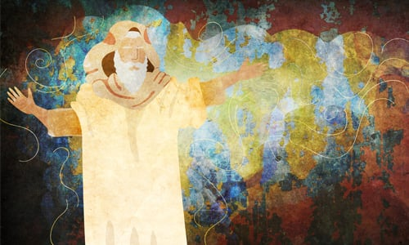

***Art by***[***Sefira Lightstone***](https://www.chabad.org/3159160)

Mount Sinai was the site of great drama, but G‑d told Elijah that His eternal place is not in great noises and rumbling earthquakes. Rather, He can be found in our quiet, humble day-to-day actions. His message was clear: “You don’t belong here. Go back to the people and do your work!”

**Honoring the Place**

Perhaps the rabbis’ attitude toward Mount Sinai can best be explained by the following piece of Talmud:

It is not the place that honors the person; rather, the person honors his place, as we found with regard to Mount Sinai, that as long as the Divine Presence rested upon it, the Torah said: “Nor let the flocks nor the herds graze before that mountain.”[2](javascript:doFootnote('2a4021233');) Once the Divine Presence departed from the mountain, the Torah said: “When the *shofar* sounds long, they may come up to the mountain”[3](javascript:doFootnote('3a4021233');) [indicating that the sanctity was not intrinsic to the place, but was due to the Divine Presence resting there].[4](javascript:doFootnote('4a4021233');)

Mount Sinai itself was not inherently holy. Rather, what was done there gave honor and holiness to Sinai, so once the people received the Torah and moved on, Sinai was no longer holy.

We read a similar story from the [Talmud](https://www.chabad.org/library/article_cdo/aid/2537389/jewish/Talmud.htm):

Rabbah bar bar Chanah said: “Once we were traveling in the desert, and we were accompanied by a certain Arab. . . . That Arab also said to me: ‘Come, I will show you Mount Sinai.’ I went and saw that scorpions were encircling it, and they were standing as high as white donkeys . . .”[5](javascript:doFootnote('5a4021233');)

The commentaries explain that scorpions represent the forces of evil. Once the Divine Presence left the place, it became susceptible to unholiness.

Thus, though Sinai was holy during the giving of the Torah, once it had accomplished its purpose it was void of significance. At Sinai we were given a mission to learn the Torah and uplift and refine the mundane, outside world. Simply hanging around Mount Sinai would defeat the purpose.

But it does not end there.

**The Return of Mount Sinai**

The Talmud states that in the messianic era, all of the synagogues of the diaspora will be transported to the Land of Israel:

Rabbi Elazar HaKappar says: “In the future, the synagogues and the study halls in Babylonia will be transported and reestablished in the Land of Israel, as it is stated: ‘Surely, like Tabor among the mountains, and like Carmel by the sea, so shall he come.’[6](javascript:doFootnote('6a4021233');)

There is a tradition that these mountains came to Sinai at the giving of the Torah and demanded that the Torah should be given upon them. We can therefore extrapolate: Just as Tabor and Carmel, which came only momentarily to Torah, were relocated and established in Israel in reward for their actions, all the more so should the synagogues and study halls in Babylonia, in which the Torah is read and disseminated, be relocated to Israel.”[7](javascript:doFootnote('7a4021233');)

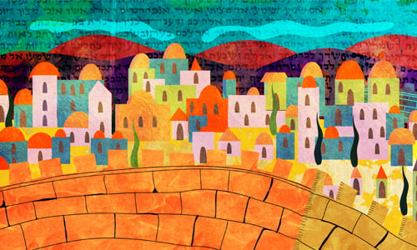

***Art by***[***Sefira Lightstone***](https://www.chabad.org/3159160)

Commentaries explain that this refers to all the synagogues from throughout the generations. Since the Divine Presence rested upon them, and they were considered holy places, their holiness is never entirely erased, and they will be transported to the Land of Israel.

In a fascinating talk, the Lubavitcher Rebbe explains that if this is true for all the synagogues and houses of Torah learning, then it is surely true for Mount Sinai itself, which was in a sense responsible for all the future generations’ learning of Torah and performance of mitzvahs. Thus, in the messianic era, Mount Sinai will regain its holiness and be transported to the Land of Israel.[8](javascript:doFootnote('8a4021233');)

May it be speedily in our days!

**FOOTNOTES**

[1.](https://www.chabad.org/library/article_cdo/aid/4021233/jewish/Where-Is-Mount-Sinai.htm" \l "footnoteRef1a4021233) I Kings 19.

[2.](https://www.chabad.org/library/article_cdo/aid/4021233/jewish/Where-Is-Mount-Sinai.htm" \l "footnoteRef2a4021233) [Exodus 34:3](https://www.chabad.org/9895#v3).

[3.](https://www.chabad.org/library/article_cdo/aid/4021233/jewish/Where-Is-Mount-Sinai.htm" \l "footnoteRef3a4021233) [Exodus 19:13](https://www.chabad.org/9880#v13).

[4.](https://www.chabad.org/library/article_cdo/aid/4021233/jewish/Where-Is-Mount-Sinai.htm" \l "footnoteRef4a4021233) Talmud, Taanit 21b.

[5.](https://www.chabad.org/library/article_cdo/aid/4021233/jewish/Where-Is-Mount-Sinai.htm" \l "footnoteRef5a4021233) Talmud, Bava Batra 74a.

[6.](https://www.chabad.org/library/article_cdo/aid/4021233/jewish/Where-Is-Mount-Sinai.htm" \l "footnoteRef6a4021233) [Jeremiah 46:18](https://www.chabad.org/16043#v18).

[7.](https://www.chabad.org/library/article_cdo/aid/4021233/jewish/Where-Is-Mount-Sinai.htm" \l "footnoteRef7a4021233) Talmud, Megillah 29a.

[8.](https://www.chabad.org/library/article_cdo/aid/4021233/jewish/Where-Is-Mount-Sinai.htm" \l "footnoteRef8a4021233) See Sefer Hasichot 5749, vol. 2, p. 464, fn. 77; Torat Menachem 5748, vol. 3, p. 354.

i